TRACKING OF MICROSCOPIC HUMAN PARASITES

HCI 575 2014 PROJECT REPORT

Zach Njus Andrew Lilja Sarat Chandra

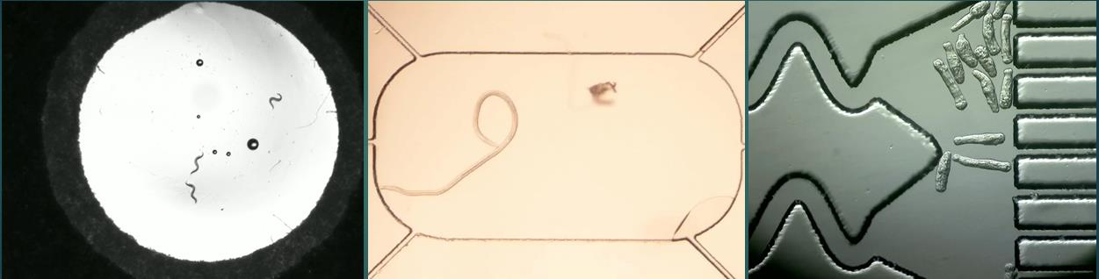

TABLE OF CONTENTS

- Abstract

- Introduction
2.1 Motivation: Brief Overview
2.2 Target Audience
3. Biological Features
3.1 Parasite
3.2. Caenorhabditis elegans
3.3. Schistozoma Mansoni
3.4. Brugia Malayi

4. Challenges

4.1 Background Subtraction
4.2 Detection and Tracking
4.3 Occlusions
4.4 Video Quality

5. Proposed Approach

5.1 Requirements
5.2 Worm Tracking
5.2.1 Method
5.2.3 Data Flow
5.2.4 Algorithm
5.3 Calculation of the Parameters
5.3.1.Velocity
5.3.2.Curvature
5.3.3.Length

6.Evaluation
6.1 Testing
6.2 Results

7.Future Improvements

8. References

1.Abstract

The application of computer vision to a biological organism has been around for many years. Even the field being as old as it is there is still much room for improvement. Developing an automated worm tracker means that instead of basing judgments about organism health on qualitative assessments and “best guesses,” experimenters can calibrate a system to extract patterns of behavior and physiological changes that indicate an organism’s phenotype.

Using an automated system means other scientists can review the methodology used to assess organisms and determine if the system standards were appropriate for the experiment conducted. Common cases can be reviewed and reused by other experimenters, instead of relying on the subjective judgment of an individual experimenter. Additionally, this analysis is a non-destructive process that can be repeated well after the original samples are gone. New standards need to be applied to existing data, allowing changes to data analysis without necessitating the entire experiment to be restarted.

Automating worm tracking also allows for the number of samples to increase. Instead of requiring experimenters to manually and regularly observe how organisms are responding to treatments, an automated system can monitor changes in behavior and physiology and alert users when something has changed. It can also be used to process a large number of recorded videos to determine how many samples were affected by a treatment, how long until measurable effects were present, and what sort of behavior the worms exhibited. By automating these tasks, the time saved can be used to increase the number of samples.

2.Introduction

2.1 Motivation: Brief Overview

Worm tracking software does exist already, but presently it has a wide range of limitations. One very large drawback is that nearly all trackers work exclusively with C. elegans, the common model organism. Typically, specific and expensive hardware is required, including laser trackers and optical filters. Many can only tack a single worm in detail, and those that can track more targets often are unable to do more than measure the centroid. These software packages are expensive, with powerful single worm trackers costing $3,500, and multi-worm trackers costing upwards of $7,000.

Our proposed system will be able to counter many of these drawbacks. By expanding our focus to three different organisms, our system will be flexible enough to track a wide range of worms with different physiology. While a C. elegan moves quickly, using a sinusoidal undulation of its body, other nematodes such as Brugia Malayi, have unpredictable, rapid movement patterns. Other organisms such as shistosomes, move by expanding and contracting their bodies, and our system will be able to track them as well.

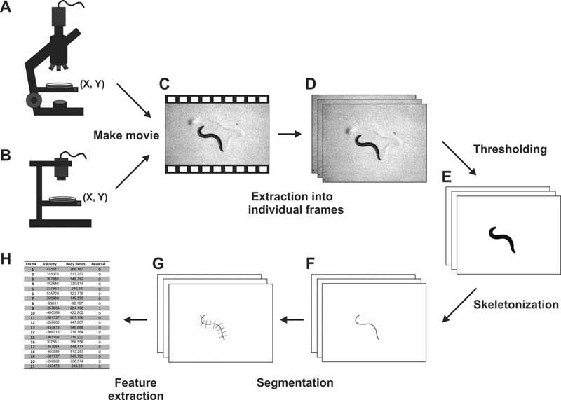
Figure 1. Most worm trackers use the same workflow to detect the organims. First, movies are recorded and individual frames are selected. Next, image processing techniques are used to determine the worm’s location and locate its center, midline, and skeleton.

In order to effectively determine the health of organisms, centroid tracking is insufficient. Information about motion, size, and location are necessary, and the best way to monitor each of these elements is by determining the worm’s centerline and curvature, effectively tracking the organism’s skeleton. We will follow similar steps used in other worm trackers (Figure 1). Worms will be individually isolated from the background, with additional steps taken to find midlines and skeletons.

2.2 Target Audience

Scientists in the field of nematology, especially those interested in the kinematics of an organism would find this program extremely useful. Currently the most robust worm tracking packages make many assumptions on how the worm moves to deal with occlusions and noisy data. Since these programs are designed mainly for C. elegans someone studying brugia malayi or shistosoma mansoi are not able to use these programs. We seek to serve a very wide audience base with our program by not allowing ourselves to make the same assumptions about organism movement and video noise.

3.Biological Features

3.1 Parasite

A parasite is an organism that lives on or in a host organism and gets its food from or at the expense of its host. Parasitism is a non-mutual symbiotic relationship between species, where one species, the parasite, benefits at the expense of the other, the host. Unlike predators, parasites do not kill their host. They are also generally much smaller than their host, and will often live in or on their host for an extended period of time. Both are special cases of consumer-resource interactions. Parasites show a high degree of specialization, and reproduce at a faster rate than their hosts. Classic examples of parasitism include interactions between vertebrate hosts and diverse animals such as tapeworms, flukes, the Plasmodium species, and fleas.

Parasites reduce host biological fitness by general or specialized pathology, such as parasitic castration and impairment of secondary sex characteristics, to the modification of host behavior. Parasites increase their fitness by exploiting hosts for resources necessary for their survival, e.g. food, water, heat, habitat, and transmission.

Although parasitism applies unambiguously to many cases, it is part of a continuum of types of interactions between species, rather than an exclusive category. Particular interactions between species may satisfy some but not all parts of the definition. In many cases, it is difficult to demonstrate that the host is harmed. In others, there may be no apparent specialization on the part of the parasite, or the interaction between the organisms may be short-lived.

For our project we will be using C.elegans as our model organism, for various reasons discussed in the preceding topics. We will be predominantly working on the two human parasites Brugia Malayi (nematode) and Schistosoma mansoni (flatworm).

3.2 Caenorhabditis elegans

Caenorhabditis elegans is a microscopic, soil- dwelling roundworm that has been powerfully used as a model organism.It was initially proposed as a model for developmental biology because of its invariant body plan, ease of genetic manipulation and low cost of maintenance. Since then C. elegans has rapidly grown in popularity and is now utilized in numerous research endeavors, from studying the forces at work during locomotion to studies of neural circuitry.

The worm’s simple genetics, transparent body, and ease of cultivation makes them an ideal system for studying embryonic

Figure 2. Internal Organs of Caenorhabditis elegans
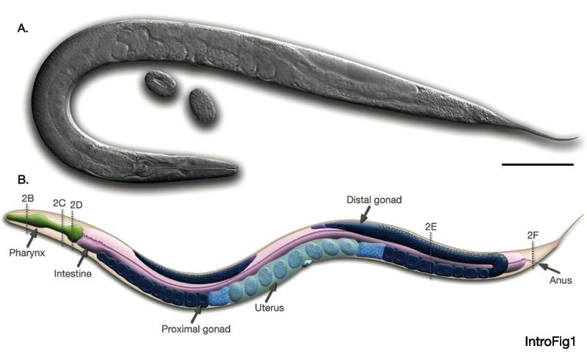

development, neuronal functions, lifespan and aging, and molecular basis of some human diseases.

Caenorhabditis elegans belongs to the phylum Nematoda of the animal kingdom. C. elegans are multicellular organisms that are approximately 1 mm long. They have elongated cylindrical body with no segmentation and no appendages. The worms have a transparent body throughout their life cycle, and exist as hermaphrodites and males. The hermaphrodites are capable of both self-fertilization and mating with males.

Nematodes live primarily in the soil with a constant level of moisture and oxygen.In the laboratory, they are cultured in agarose-containing Petri dishes on a lawn of the bacteria E. coli. The life span of the worm is about 14 days. They go through 4 larval stages, L1 through L4, as they mature from an egg to an egg-laying parent. The development of worms is affected by temperature, and in the laboratory, they are cultured at 15 °C, 20 °C or 25 °C.

C.Elegans as Model Organism

C.elegans are considered to be the most powerful model organism for various reasons. Firstly, it is relatively inexpensive and easy to culture worms on either solid or liquid medium.

Second, as they remain transparent throughout their life cycle, the entire worm anatomy is easily viewed by light microscopy. This attribute is particularly useful for studying worm development, as individual cell lineages can be easily traced. Transparency also allows fluorescent reporters, such as Green Fluorescent Protein (or GFP), to be easily viewed in live worms.

Third, C. elegans are very fertile; each hermaphrodite lays about 300 eggs following self-fertilization. Therefore, it is easy to obtain worms in large numbers. Also, worms reach reproductive maturity in only
3.5 days at 20 °C.

Fourth, worms are easy to manipulate genetically. By examining mutations, researchers gain insight into gene function, and mutations can be introduced in worms by treatment with chemicals and by exposure to UV radiation. High-throughput genome-wide screens are easy to perform with worms in 96 well plates. This allows numerous genes to be simultaneously screened for their involvement in a particular biological phenomenon or behavior. Also, the C. elegans genetic center, or CGC, maintains a large repository of mutants, which are available to researchers for a small fee.

Fifth, C. elegans was the first multicellular organism to have a completely sequenced genome. The complete sequence, and a detailed chromosomal map, has made genetic analysis faster and easier. Sequence analysis shows that many genes are conserved between humans and worms.

Finally, in addition to all these advantages, the worm research community is very friendly, and has developed many helpful online resources for studying worms.

Life Cycle

Embryonic Development : The development of C. elegans is known in great detail because this tiny organism (1 mm in length) is transparent .C. elegans generally reproduces as a self-fertilizing hermaphrodite, with each animal producing BOTH sperm and eggs. Two reflexed gonadal arms (each of which contains an ovary, oviduct, spermatheca, and uterus) terminate at the vulva, located midway along the ventral side. The mature hermaphrodite is effectively a female because the gonad has first made and stored sperm before turning to the production of oocytes. Eggs (developing embryos) are

fertilized by endogenous sperm and then undergo some development inside the parental hermaphrodite. Embryos are arranged along the uterus with the most developed ones found nearest the vulva. Fertilized eggs are covered with a chitinous shell and, when mature enough, are deposited on the agar surface. Embryogenesis occurs in about 12 hours.

Post-Embryonic Development: A newly hatched animal resembles an adult in general proportions and body movement, but is only about one-sixth the length of an adult. During growth, developing larvae undergo four molts in which the old cuticle is shed and replaced by a new underlying cuticle. The inter- molt stages are designated L1 through L4, followed by adulthood. L3 and L4 hermaphrodites can be distinguished from adults via the presence of half-moon shaped structure in the area of the vulva. Worms stop pharyngeal pumping and become lethargic while molting. During growth at 20°C, molting occurs at approximately 14, 22, 30, and 40 hours after hatching, with egg laying commencing at about
50 hours. During larval development, the number of non-gonadal cells increases from about 550 in the newly hatched L1 to about 810 in the mature hermaphrodite and to about 970 in the mature male. At hatching the L1 has only 4 gonadal cells. These cells proliferate to form the adult reproductive system of approximately 2500 nuclei.

Development from external egg deposit to the adult stage occurs in 2.5 days, and the worm's life span is
2-3 weeks. The entire life cycle takes about 3 1/2 days at 20°C with each adult hermaphrodite producing
250-350 progeny.

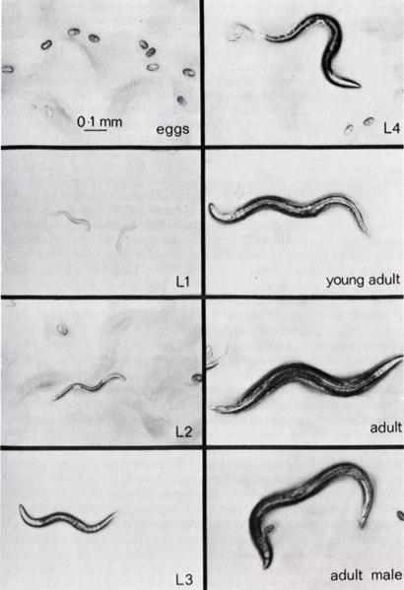
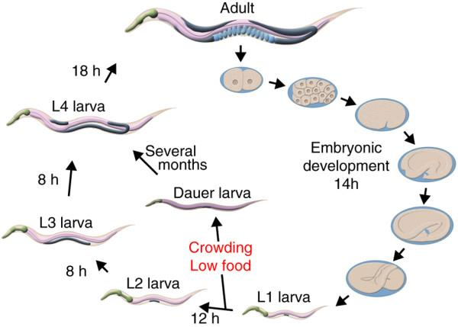

Figure 3. Life cycle of C. elegan

3.3 Schistozoma Mansoni

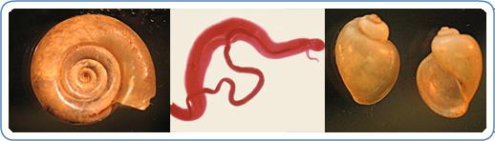

Figure 4. Schistozoma Mansoni

Schistosoma mansoni is a significant parasite of humans, a trematode that is one of the major agents of the disease schistosomiasis. The schistosomiasis caused by Schistosoma mansoni is intestinal schistosomiasis. More than 200 million people are infected worldwide. It is second only to malaria as the most devastating parasitic disease. Schistosomiasis is considered one of the Neglected Tropical Diseases (NTDs). Schistosomes are atypical trematodes in that the adult stages have two sexes (dioecious) and are located in blood vessels of the definitive host. Most other trematodes are hermaphroditic and are found in the intestinal tract or in organs, such as the liver.

Life Cycle

Eggs are eliminated with feces or urine. Under optimal conditions the eggs hatch and release miracidia which swim and penetrate specific snail intermediate hosts. The stages in the snail include two generations of sporocysts and the production of cercariae. Upon release from the snail, the infective cercariae swim, penetrate the skin of the
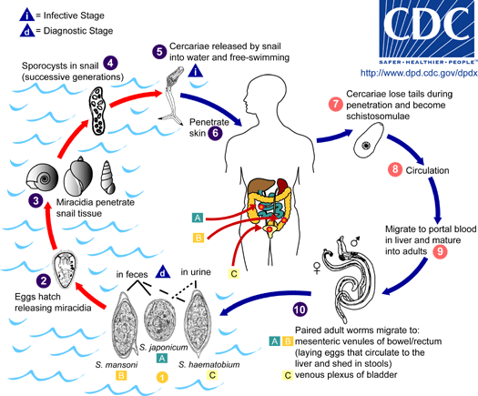

human host and shed their forked tail, becoming schistosomulae. The schistosomulae migrate through several tissues and stages to their residence in the veins. Adult worms in humans reside more often in the superior mesenteric veins draining the large intestine. The females (size 7 to 20 mm; males slightly smaller) deposit eggs in the small venules of the portal and perivesical systems. The eggs are moved progressively toward the lumen of the intestine and of the bladder, and are eliminated with feces or urine, respectively. Pathology of schistosomiasis includes: Katayama fever, hepatic perisinusoidal egg granulomas, Symmers’ pipe stem periportal fibrosis, portal hypertension, and occasional embolic egg granulomas in brain or spinal

cord. Human contact with water is thus necessary for infection by schistosomes.
Figure 5. Life cycle of Shistozoma Mansoni

3.4 Brugia Malayi

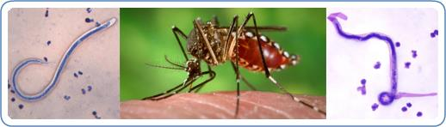

Figure 6. Brugia malayi

Brugia malayi is a nematode (roundworm), one of the three causative agents of lymphatic filariasis in humans. Lymphatic filariasis, also known as elephantiasis, is a condition characterized by swelling of the lower limbs. Brugia malayi is transmitted by mosquitoes and is restricted to South and South East Asia. It is one of the tropical diseases targeted for elimination by the year 2020 by the World Health Organization. Lab subjects are cultured in infected mosquitos in BSL2 labs

Life Cycle

The typical vector for Brugia malayi filariasis are mosquito species from the genera Mansonia and Aedes. During a blood meal, an infected mosquito introduces third-stage filarial larvae onto the skin of the human host, where they penetrate into the bite wound. They develop into adults that commonly reside in the lymphatics. The adult worms resemble those of Wuchereria bancrofti but are smaller. Female worms measure 43 to 55 mm in length by 130 to 170 μm in width, and males measure 13 to 23 mm in length by 70 to 80 μm in width. Adults produce microfilariae, measuring 177 to 230 μm in length and 5 to 7 μm in width, which are sheathed and have nocturnal periodicity. The microfilariae migrate into lymph and enter the blood stream reaching the peripheral blood. A mosquito ingests the microfilariae

Figure 7. Life cycle of Brugia Malayi

during a blood meal. After ingestion, the microfilariae lose their sheaths and work their way through the wall of the proventriculus and cardiac portion of the midgut to reach the thoracic muscles. There the microfilariae develop into first-stage larvae and subsequently into third-stage larvae. The third-stage larvae migrate through the hemocoel to the mosquito's prosbocis and can infect another human when the mosquito takes a blood meal.

4. Challenges

We foresee three main challenges for this project: background subtraction, locating the organisms and sorting through occlusions. Since each organism has a very different phenotype from the others one encompassing solution likely does not exist. Different techniques must be employed based on the visual information present in a scene, and effectively integrating this data is a critical part of ensuring accurate and efficient tracking.

4.1 Background Subtraction

All of the organisms used in this project are semi-transparent organisms, meaning that parts of their body will be clear and thus look like the background. If the images are improperly thresholded and the organisms are not completely segmented out this will cause many problems later on with morphological operations.

All three organisms are mobile in the videos we will be examining so we can use standard mean background subtraction combined with region of interest filling to segment the organisms from the background. After this our plan is for the user to specify a value used for thresholding and then the user will be given a sample frame to ensure that the value was correct. If the value was not correct the user will be given another opportunity to specify a new value.

Figure 8. Basic thresholding and skeletonization of
Brugia Malayi

Since we want our software to work with old shistosome videos, before microfluidics, we will not be able to solely rely on background subtraction. For these videos we will be putting a greater focus on edge detection, from which we can fill in the body and get their centerline.

4.2 Detection and Tracking

Of the organisms involved in this project there are two that are highly mobile and one that is relatively sedentary. In regards to the mobile organisms keeping track of the head and tail of the worm will be very crucial as nearly all parameters measured require consistent indexing of points.

A filter such as a Kalman filter could prove very useful in this situation. Using a Kalman filter to estimate the location of the head and tail will increase the probability that we do not mistakenly identify the head in one frame as the tail in the next.

4.3 Occlusions

Finding a set of n points along a non-branching line is very elementary, the problem with occlusions in the introduction of any number of branch points. When the program reaches a point like this it much make a decision as to which direction it should go, here lies the most difficult challenge of this project. A secondary problem occurs when a large section of a worm or multiple worms occlude with one another, this causes the skeleton of the worm to identify the interface between the two sections instead of the actual centerline of the worm. This causes many problems such as but not limited to identifying individual organisms and the centerline of an organism.

We have many ideas on how to minimize this problem but no way of telling which one will produce the best result.

• The particle filter would be very powerful to ensure that even occluding worms (multiple worms) could be separated and analyzed individually.
• We are assuming that we have to incorporate the previous skeleton data to the current image to help navigate branch points
• A Kalman filter could possible work to choose the next point that is “in-line” with the track that
has been spanned
• As seen in other papers we have made a constrained model of a worm, that is of fixed length and the points are fixed distances from one another. As new points are found on the previous skeleton we would deform this model to fit the new skeleton in hopes that through the deformation process it would span the unknown gaps in the current skeleton.
• To minimize the problem of long sections of the worm we will have to create our own skeletonization algorithm which will mostly be an extension of a distance transformation
function. This would mean that only pixels of a certain distance from the borders of the organism would be used while those too close and too far away would be ignored.

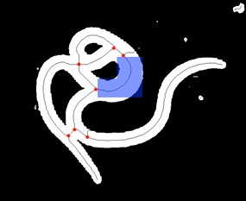
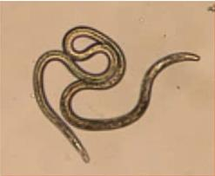

Figure 9. Blue highlighted area shows that standard skeletonization algorithm does not accurately represent the center line of the worm. Red dots indicate branch points that the program would have to traverse in correct direction.

  - Video Quality

5.Proposed Approach

  - Requirements
Software Matlab (Image Processing Tool Bar)

Hardware
Developing Computer
--Intel® Core i7 CPU
-- 4 GB Memory
-- Installed Windows® 7

  - Tracking Methodology
By careful scrutiny of the videos of C.elegans and Brugia malyi, it is observed that both these worms have almost similar sinusoidal lateral locomotion. Schistosomulae, conversely, exhibit a type of movement in culture that is dominated by repeated shortening and elongation of the body. Hence we have devised independent methodologies for Brugia malayia and Schistosoma mansoni.

Schistoma mansoni
Schistosomulae as mentioned earlier exhibit a type of movement that involves shortening and elongation of the body. Adult schistosome are also observed to exhibit irregular thrashing and whip-like movements.

Algorithm: Mass-Spring System
Schistosoma move by expanding and contracting their bodies, making a fixed-mesh system difficult to use for tracking. Instead, this algorithm uses a modified mass-spring system to automatically match the changing dimensions of the parasite's body. After calculation of edge points on the image of the schistosome, the mass-spring system moves existing edge nodes to these points and calculates appropriate locations of the rest of the skeleton.

A mass-spring system is generally defined as two nodes connected by an elastic spring. Each node has mass, position, velocity, acceleration, and force, and each spring has stiffness, natural resting length, and a damping value. Hooke's Law is used to calculate the force applied to each node based on these variables, and new positions are calculated. In this system, each node correlates with a point on the parasite, with mesh lines matching the springs connecting each node in a grid array. Only two nodes can be connected to one spring, and for each of the nodes, the force applied to each is provided by equation 1, where F is force, p are current node positions, k is spring elasticity, L is spring resting length, d is the spring damping, and v is the nodes' current velocity.

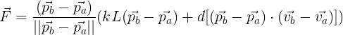

Before the model can be run, an initial mesh must be created. First, the image is processed using dilation, erosion, and thresholding to eliminate noise and create a solid binary blob, and a rough central line is found through a thinning algorithm (Figure 1a). Next, normals are calculated from the central line in two directions, extending towards the edges of the blob (Figure 1b). Intersection points between the blob and the normals are edge points and act is the initial placement locations of the edge nodes, with spinal nodes placed along the center line. Finally, the system is allowed to run for a user-specified number of iterations (usually 10-30) to reach equilibrium, the point at which the forces each node exerts on the other are approximately equal.

After the mesh has been created, no new nodes are placed. Instead, every frame, the edge points are found and attractors are placed. These have an influence on the nodes closest, with force calculated using the inverse square law to them and move them into position along the edge of the parasite. After the system has finished equalizing, the attractors are removed and their forces eliminated from the nodes. This prevents the system from overshooting or from excessive force threatening the integrity of the mesh.

The mass-spring system allows for errors in image processing to be ignored and a consistent mesh to be maintained. Due to occasional problems with skeletonization of the schistosoma, it was important that the mesh does not deform when edge points are mis-placed or out of order. Instead, the mesh finds a natural equilibrium between the current state of the system and the position of the edge nodes, accurately mapping to the shape of the parasite without being affected by artifacts in the blob. One downside to this technique is that there is rarely an exact 1:1 correlation between the parasite and the mesh, but for the majority of applications this limitation is acceptable.

Data Flow

Brugia Malayi

A defining characteristic of B. malayi, as with all nematodes, is that they only have longitudinal muscles, therefore they exhibit an S-shaped or sinusoidal motion during locomotion.

Algorithm : Binary Circle Overlap Method

Algorithm :

Brugia Malayi exhibit a sinusoidal motion, involving several twists and turns. To track the brugia, we implement the overlapping method.
In the this method, firstly after extracting the frames from the video, the worm is segmented out and the centerline is determined via user input. The skeleton is then developed and the average width of the worm is calculated by dividing the total length by the number of desired points.
(insert initial_skel.jpg)
Binary elements of the current frame are identified and the overlap areas between the previous frame and the current frame are identified. The largest labeled area in the current frame which overlaps with the previous frame is determined, which segments out the worm, eliminating the background noise.
(insert worm_overlap_blobs.jpg)

Then by using the distance transformation, determine the range of pixels falling in the range of the width of the worm, which is then used for determining the global end points. Using this method provides a much better representation of the skeleton of the nematode.
(insert compare_skeleton.jpg)

The skeleton is then broken apart by finding the branch points and deleting a square area centered on the branch points. All the sections less than a threshold, which do not contain the global points are deleted.
(insert broken_skel.jpg)

Eliminate small sections of skeleton (<10 pixels) unless they contain a global endpoint. Start searching from the global endpoint that corresponds to the largest section of skeleton.
(insert endpoint_images.jpg)

When a branch point is reached a decision must be made about which next point to traverse to. To decide this we tried many different methods.

Pixel Intensities:
Starting at the branch point the distances to all other branch points are calculated. Only branch points that have a distance less than four times the average width away are considered. Then a pixel wide line connects the current point to each of the close points individually. The pixel intensities along these lines are measured for their standard deviation. The line that has the least amount of variation in pixel values is considered to be the correct path. This method works quite well for “bump” style occlusions in which the sides of the nematode touch but no overlap is performed. However if there is an overlap there is no guarantee that it will choose the correct path as there will be a lot of variation in every path. Another weakness of this approach is how it is tied very closely to the video quality which can fluctuate a lot.

Binary Circle Overlap:

Prediction Point and Previous Skeleton:
This method tries to guess which point to jump to based off of the curve of the already determined skeleton and the skeleton in the previous frame. As the skeleton is being traversed we keep track of which point on the old skeleton we correspond to. When a branch point is reached we first calculate the velocity and acceleration in the x and y directions based on the previous 15 points of the new skeleton. Then an initial prediction is made based on how far away each close point is. This initial prediction is then averaged with the location of the old skeleton point to give a new prediction. This averaging was necessary as pixels are measure in integer values so they do not provide nice smooth curves which work better for velocity and acceleration calculations.
(insert branch point prediction and branch point prediction zoomed)

1. Ask the user to define a region where the worm is in the first frame to develop a background and use ROI fill to fill it in.

2. Use background subtraction to segment out the worm.

3. Ask the user to select points along the centerline of the worm

4. Develop a skeleton and find the average width of the worm based off of the number of points defined. This can also be user inputed

5. Do background subtraction on the next frame to segment out the worm, same as in the first frame.

6. Use bwlabel to label all binary elements of the current frame

7. Find all of the overlap areas between the previous frame and the current frame.

8. Find the largest labeled area in the current frame that overlaps with something from the previous frame.

Steps 6-8 ensure that only the worm is segmented and no other objects are brought in.

9. Use bwdist to do a distance transformation

10. Then find the pixels with the range of distances between .7 and 1.8 of the average width. These values were found through trial and error

11. Find the global endpoints of the worm.

12. Break apart the skeleton by finding branch points and then deleting a 3x3 box centered on the branch points.

13. Eliminate small sections of skeleton (<10 pixels) unless they contain a global endpoint

14. Start searching from the global endpoint that corresponds to the largest section of skeleton.

15. If a branch point is reached, then find a pixel line that connects it to close points and analyze the values of the pixels connecting the two.

16. Pick the line that has the least amount of variation in pixel values

17. Continue until the length of the worm has been reached or there is no other point to jump to.

Data Flow

  - Calculation of Parameters

5.3.1 Velocity : The minimum distance between corresponding points in two adjacent frames. Normal and lateral components can be calculated from the velocity term once an axis of projection is found.

Vn =
2
2
((x1 − x2 )
+ ( y1 − y2 )
) / frame _ rate

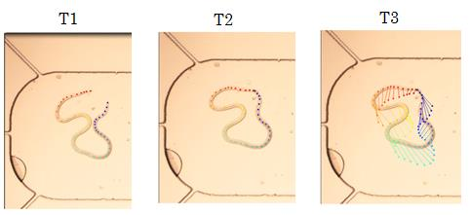
Figure 10. Images showing progression from T1 to T2 and the velocity vectors representing the movement

5.3.2 Curvature : The measure of change in tangent angle along the centerline of the body. From curvature data it is also possible to extract the wavelength of an organism and even the frequency of movement.

Figure 11. Blue color indicates a concave section of the worm body while red indicates a convex section. The striped pattern arises from sinusoidal movement.

5.3.3 Length: The change in length of the centerline of the body over time. Contraction rate is directly tied to length as a “pump” would be when the body extends to its maximum length followed by a contraction to its minimum length. A threshold percent will have to be determined to match previously human recorded data.
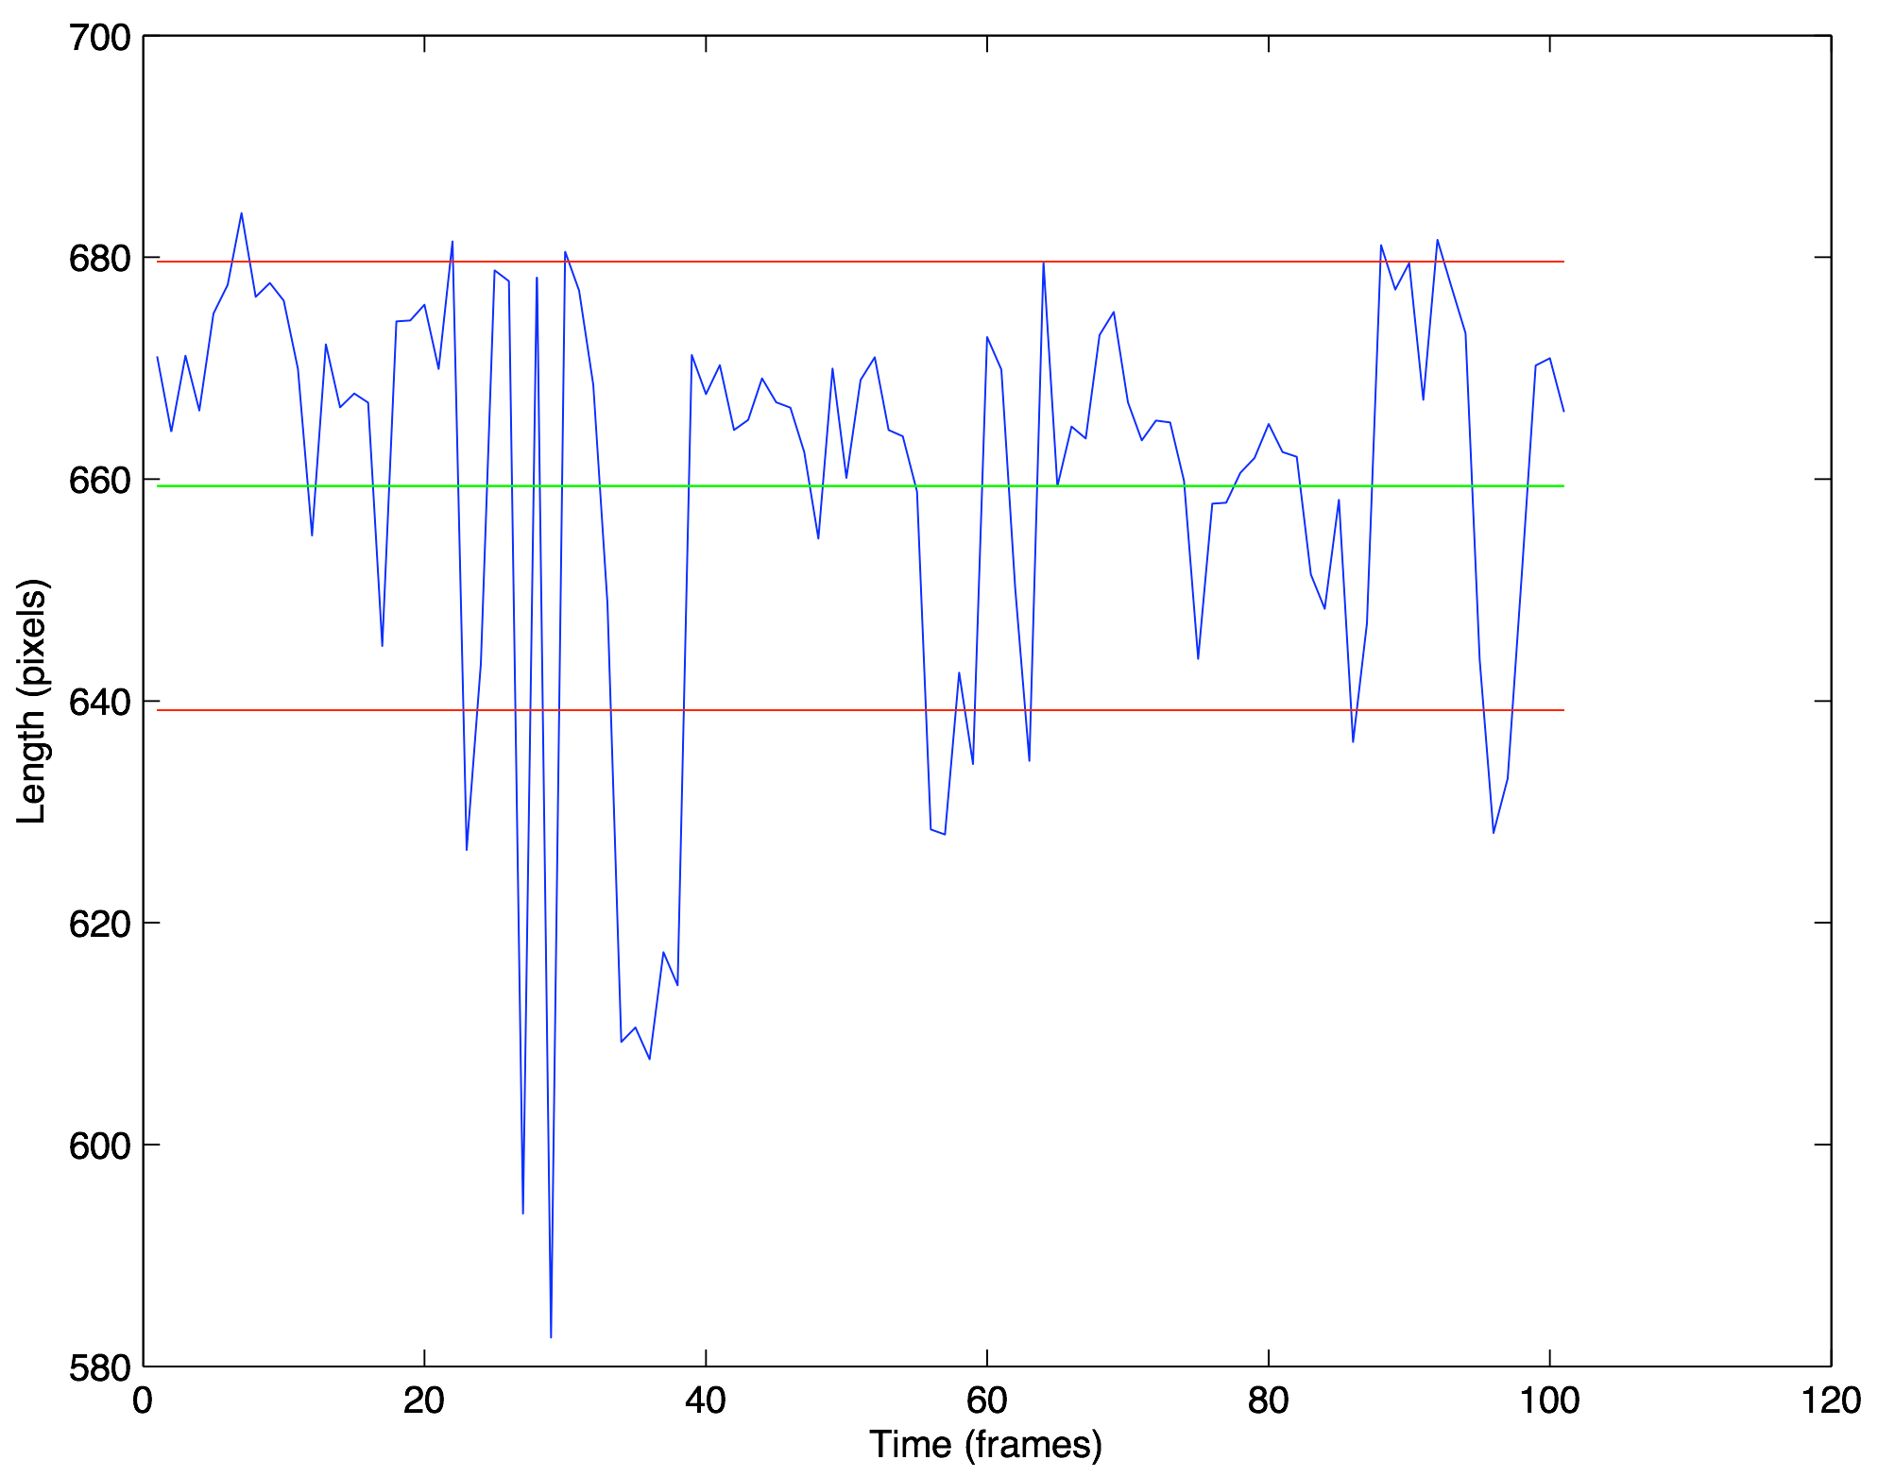
Figure 12. Overall length of skeleton of the organism for each frame of the video. Green line is average length with red being +/- standard deviation of length.

Back-Ground Subtraction
Center-line of the worm is determined
Normals are extented from the centre-line in two directions
System is allowed to run until the equilibrium is reached
After the mesh is created, in every frame the edge points are found and the attractors are placed
After the system is in equilibrium the attractors are removed and their forces eliminated from the nodes
Extract the frames from the video file
Attractors are then positioned along the edge of the parasite determined by the calculated force

Attractors are then positioned along the edge of the parasite determined by the calculated force
Attractors are then positioned along the edge of the parasite determined by the calculated force
Attractors are then positioned along the edge of the parasite determined by the calculated force

Back-Ground Subtraction using ‘rofill’ and ‘roipoly’
User selects the points along the centre-line of the worm
'Spline' function converts uneven user defined points to smooth evenly spaced points
Segment out the next frame
Find the overlapping regions of the previous and current frame
Complete or No Overlap?
Calculate the magnitude and direction of partial overlap
The circle is then moved over by the calculated amount, and the process is repeated for the next frame
Extract the frames from the video file

6. Evaluation
6.1 Testing

Schistosoma Mansomi

Brugia Malayi

To test the tracking algorithms for brugia malayi a set of three videos were randomly selected from a database of videos. The code was then run on the videos and was considered successful on those frames that it did not incorrectly identify a section of the worm. An incorrect identification is defined as either eliminating a significant portion of the worm (two times average width ) or by incorrectly identifying the order of points on the worm.
(insert end elimination and incorrect path images)
6.2 Results and Future Improvements
The algorithm proved to be very accurate throughout the video provided that the contrast between the worm and the substrate was high. If the edges of the worm became blurred there was a much more likely chance of the worm not being fully segmented out.

The main area that this algorithm could be improved on is in the traversal of break points. One main limitation currently is that we are using a combination of two singular points combined with a single distance measurement to make a decision on which path to take. We had been working on but had not completed another version of the algorithm that would not only look at a single point but would look at the entire proposed section. The section would be analyzed as if we had chosen that path and then compared to the old skeleton. This allows for the formation of loops to be preserved and thus the order of points to be maintained.

Other more cosmetic areas for improvement are the user interface. Currently the code is run from a MATLAB script and variables are not entirely obvious to find and set. A GUI would be able to provide a set list of user modifiable variables along with a neat visual output and recording options.

5. References

[1] Geng W., Cosman P., Berry C. C., Feng Z., Schafer W. R. (2004). Automatic tracking, feature extraction, and classification of C. elegans phenotypes. IEEE Trans. Biomed. Eng. 51, 1811–
1820.10.1109/TBME.2004.831532

[2] K.M. Huang, P. Cosman, and W.R. Schafer, “Automatic tracking of multiple c.elegans with articulated models,” in Proceedings of International Symposium on Biomedical Imaging. IEEE, 2007, pp. 1240–1243.

[3] E. Fontaine, J. Burdick, A. Barr Automated tracking of multiple C. elegans Conf Proc IEEE Eng Med Biol
Soc, 1 (2006), pp. 3716–3719

[4] Huang K-M, Cosman P, Schafer WR: Automated detection and analysis of foraging behavior in
Caenorhabditis elegans. J Neurosci Methods 2008, 171:153-164.

[5] Albrecht DR, Bargmann CI (2011) High-content behavioral analysis of Caenorhabditis elegans in precise spatiotemporal chemical environments. Nat Methods 8(7):599–605.

[6] Moore BT, Jordan JM, Baugh LR (2013) WormSizer: High-throughput Analysis of Nematode Size and
Shape. PLoS ONE 8(2): e57142. doi:10.1371/journal.pone.0057142

[7] Wang SJ, Wang Z-W (2013) Track-A-Worm, An Open-Source System for Quantitative Assessment of C. elegans Locomotory and Bending Behavior. PLoS ONE 8(7): e69653. doi:10.1371/journal.pone.0069653

[8] Moore BT, Jordan JM, Baugh LR (2013) WormSizer: High-throughput analysis of nematode size and shape. PLoS ONE 8: e57142. doi: 10.1371/journal.pone.0057142

[9] Kenwright, B., Davison, R., Morgan, G. (2011) Real-Time Deformable Soft-Body Simulation using Distributed Mass-Spring Approximations. Proceedings of the Third International Conference on Creative Content Technologies.

[1] Wikipedia (www.wikipedia.com)

[11] Center for Disease Control (www.cdc.gov)

[12] Journal of Visual Experiments(www.jove.com)

[12] OpenWetWare (www.openwetware.org)

[13] Genomebiology (www.genomebiology.com

